Project Name |  | Confidentiality Level
XX Project |  | For Recipients’ Reference Only
Project ID | Version | Document Code
58888 | 1.0

DBMS Software Requirements Specification

Revision Record
Date | Revision Version | CR ID /Defect ID | Sec No. | Change Description | Author
2017-4-28 | 1.0
Content
1 Introduction 6
1.1 Purpose 6
1.2 Scope 6
2 General description 6
2.1 Software perspective 6
2.1.1 About the Project 6
2.1.2 Environment of Product 6
2.2 Software function 6
2.3 Actors 6
2.4 User characteristics 6
2.5 Assumptions & Dependencies 7
2.6 System Use Case 7
2.7 Sub-module Functional Requirements 1 7
2.7.1 Functional Requirements1 7
2.7.2 Functional Requirements2 8
2.8 Sub-module Functional Requirements2 9
2.8.1 Functional Requirements1 9
2.8.2 Functional Requirements2 9
2.9 Data Information 9
3 Interface Requirements 9
3.1 User Interface 9
3.2 Software Interface 10
4 Overall Design Constraints 10
4.1 Hardware Limitations 10
4.2 Technology Limitations 10
5 Software Quality Attributes 10
6 Requirements Classification 10

Keywords: DBMS、RDBMS、MFC、SDI Dialog、C/S 、MVC
Abstract :This system is the version of the database management system, including database creation, database table management, record addition and query, index creation and implements, multi-user, concurrency processing, transaction procession, database backup and recovery, etc. This document describes the design of each functional module to help the software developers analyze and design the software better. At the same time, it helps the clients to give better suggestions.
List of abbreviations :
Abbreviations | Full spelling | Chinese explanation
SDI | Single Document Interface | 单文档界面
MFMFC | Microsoft Foundation Classes | 微软基础类库
DBMS | Relational Database Management System | 关系型数据库管理系统
C/S | Client/Server | 客户/服务器模式
MVC | Model View Controller | 模型（model）—视图（view）—控制器（controller）

Introduction

Purpose

This manual describes user requirements for functions and performance of the Database Management System. The intended audience includes:

Users
Project administrators
Testers
Designers
Developers
The manual focuses on function requirements of Database Management System; clarifies mandatory functions, performance and interfaces of the developed software; assists system analysis and software developers in user demand-orientation.

1.2 Scope
The manual analyzes the logical model of the Database Management System from users’ perspective. It answers the question “What does the system do?” by listing functions and services provided to clients. The manual omits development skills, but describes user requirements through demand analysis and model establishment. It is a common ground for game users, developers and other participants to communicate.

General description

Software perspective

About the Project

Database Management System is large-scale software which can manipulate and manage the database. It is used to establish, use and maintain the database, and called DBMS for short. It manages and controls the database in a unified manner to ensure the security and integrity of the database. The user accesses the data in the database through DBMS. The database administrator also maintains the database through DBMS. It can make many applications and users establish, modify and query the database through different methods at the same time or different moments. Most DBMS provide DDL and DML for users to define the schema and permission constraint of the database, and implement the data operation:add,delete,etc.

Environment of Product

The system is a Windows desktop window program. It stores the data with the the file system of the operation system. It can implement the communication between the client and server through the network.

Software function

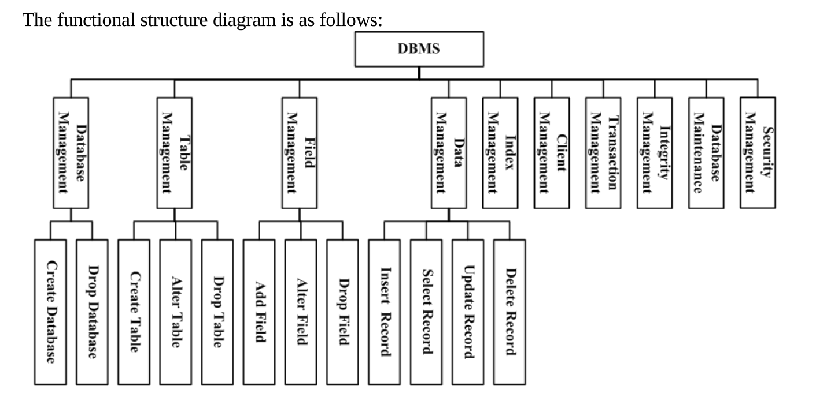

Database Management System can be divided into following modules: Database Management, Table Management, Field Management, Data Management, Index Management, Client Management, Transaction Management, Integrity Management, Database Maintenance and Security Management.
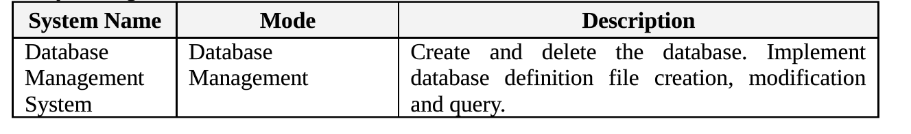
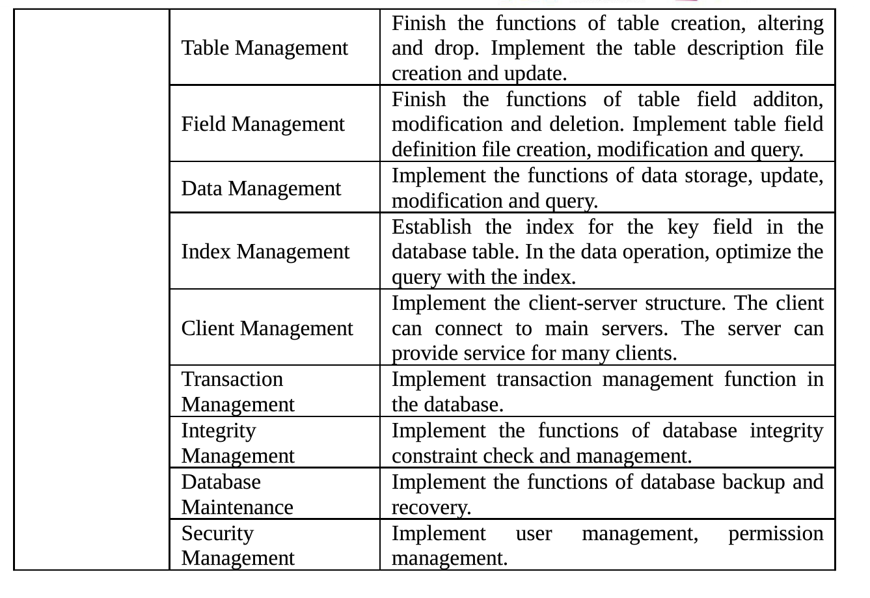

User characteristics

The users of this system are the database administrators and the client users.

The database administrator requires some database management knowledge, and can install, deploy, create, manage and maintain the database.
The client use requires some application operation knowledge, and can use this database to implement the functions of data storage, modification, query, etc.

Assumptions & Dependencies

This system generally uses the WINDOWS operating system, if users have additional operational requirements under the particular circumstances, the system should have a portable condition.

System Use Case

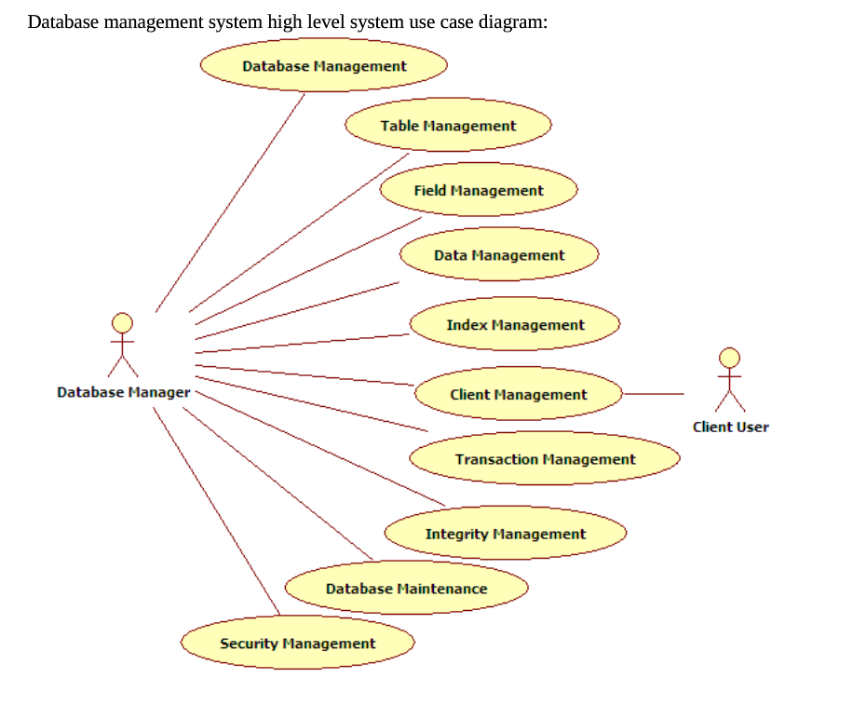

Database Management
1. Sub-module introduction
Create and delete the database. Implement database definition file creation, modification and query.

2. Sub-module use case diagram
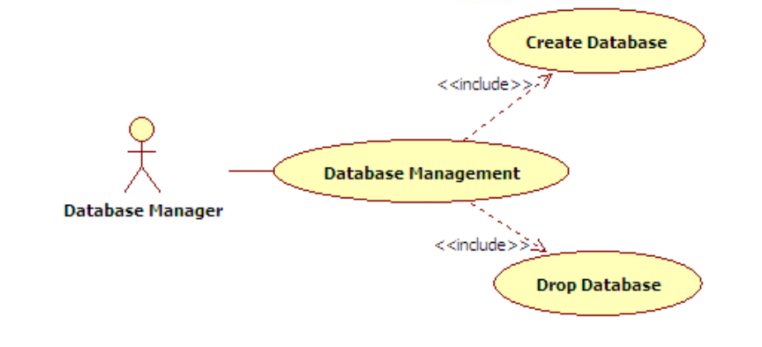

Create Database

1. Introduction
Implement the function of database creation. Corresponding SQL statement: CREATE DATABASE<database name>. The database is divided into two types; user database and system database. The system database is database Ruanko created by the system when the system is created. This database can not be deleted
2. Inputs
Database name, database date file storage path, database creation time, database type..
3. Process
（1）Determine the validity of the database name.
The length of the database name can not exceed 128 characters. If the name is too long, the database can not be created and prompt the users.
Determine whether the database name has existed. If it exists, the database can not be created and prompt the users.
- Save the database information into database file ruanko.db.
Determine whether ruanko.db file exists under the system directory. If it exists, append to the file.
If it doesn’t exist,create ruanko.db file.
- Output
Create or update database description file ruanko.file, add or delete the database information.

Drop Database
1. Introduction
Implement the function of database creation. Corresponding SQL statement: DROP DATABASE <database name>. The database is divided into two types; user database and system database. The system database is database Ruanko created by the system when the system is created. This users database can be deleted
2. Inputs
The database name, database data file storage path, database creation time,database type.
3. Process
（1）Determine whether the database exists.
（2）Determine whether the database is used by the user. If there is a user that connects to it, it can not be deleted
（3）Delete the database information from ruanko.db file.
（4）Delete all files related to the database.
4. Output
Delete the database description file in database description file ruanko.db.

Table Management

1. Sub-function Introduction

Finish the functions of table creation, modification and deletion. Implement the table description file creation and update.

Sub-function System Use Case
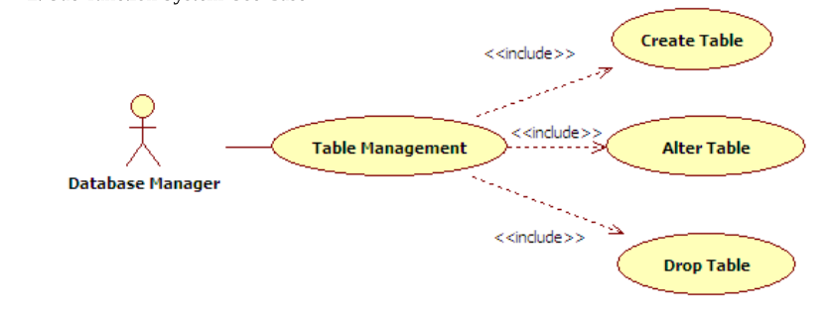

Create Table
1. Introduction
Implement database table creation function. Corresponding SQL statement: CREATE TABLE <table name>. When the table is created, add the basic information of the table into the table information file of the current database. The table description file is :[Database Name].tb.
2. Inputs
Database name, table name, table definition file path, table integrity file path, table record file path, table index file path, table creation time, last modification time(is creation time), table field count(initial is 0), total number of records in table(initial is 0).
3. Process
（1）Determine the validity of the table name
The length of the table name can not exceed 128 characters. If the name is too long, the table can not be created and prompt the user.
Determine whether the table name has exists. If it exists, the table can not be created and prompt the user.
- Get the paths of four table definition files according to the rule.
Table definition file path:[Table Name].tdf.
Table integrity file path:[Table Name].tic.
Table record file path:[Table Name].trd.
Table index file path:[Table Name].tid.
（3）Save the table information to table description file “[Database Name].tb”file. If the table information file does not exist, create the file. If it exists, append the record to the end of the file.
4. Output
Create or update the table description file:“[Database Name],tb”.

Alter Table
1. Introduction
Implement database table modification function. Corresponding SQL statement: ALTER TABLE <table name><alter table action>. When the table field is added, update the field count, record count, modification time or path in the table.
2. Inputs
Database name, table name, table definition file path, table integrity file path, table record file path, table index file path, table creation time, last modification time(is current time), table field count, total number of records in table.
3. Process
（1）Through the database name and table name, find the table information file, get the table modification information.
（2）Set the modification time
（3）Update the table information
4. Output
Update table description file:“[Database Name].tb”.

2.7.3 Drop Table

1. Introduction
Implement database table deletion function. Corresponding SQL statement: DROP TABLE <table name>.
2. Inputs
The database name and table name.
3. Process
（1）Through the database name and table name, search the table information file, get the table information.
（2）Delete the current table information.
（3）Delete the definition file and record file corresponding to the table.
4. Output
Update table description file:“[Database Name].tb”.

Field Management

1. Sub-function Introduction

Finish the functions of table field addition, modification and deletion. Implement the table field definition file creation, modification and query.

2.Sub-function System Use Case
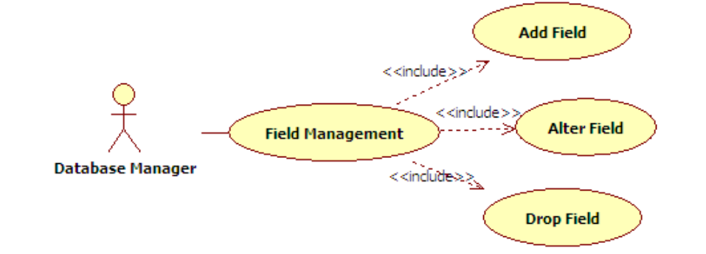

2.8.1 Add Field
1. Introduction
In created table, add fields, Corresponding SQL statement: ALTER TABLE<table name> ADD COLUMN <column name><column definition>.
2. Inputs
Database name, table name, field name, field order, field type, field type parameter, modification time(creation time), integrity constraint information(default is none).
3. Process
（1）Determine whether the table description file exists.If it does not exist ,create it
（2）Determine whether the field name is valid. If it is invalid, it can not created.
（3）Update the field information.
4. Output
Create or Update the table definition file:“[Table Name].tdf”.

2.8.2 Alter Field
1. Introduction
Modify the field information in the table.Corresponding SQL statement: ALTER TABLE<table name> MODIFY COLUMN <column name><alter definition>.
2. Inputs
Database name, table name, field name.
Modified field information:field name, field order, field type, field type parameter, modification time(creation time), integrity constraint information(default is none).
3. Process
（1）Determine whether the field exists. If it does not exist ,it fails and prompt the users.
（2）Determine whether there is a record. If there is a record, update all the records.
（3）Update the field information.
（4）Update the corresponding field information in the index.
（5）Read the original field information.
4. Output
Update record file.
Update table description file.
Update index description file.
2.8.3 Drop Field
1. Introduction
Delete the field information in the table.Corresponding SQL statement: ALTER TABLE<table name> DROP COLUMN <column name><drop behavior>.
2. Inputs
Database name, table name, field name.
3. Process
（1）Determine whether the field exists. If it does not exist , prompt the user.
（2）Determine whether the current field is used by the index . If it is used by an index, remove the corresponding index.
（3）Update the table field information, and delete the field information.
（4）Determine whether there are records. If there are records,update all records.
4. Output
Update record file.
Update table description file.
Update index description file.

2.9 Data Management

1. Sub-function Introduction

Implement the functions of data storage, update, modification and query/

2.Sub-function System Use Case
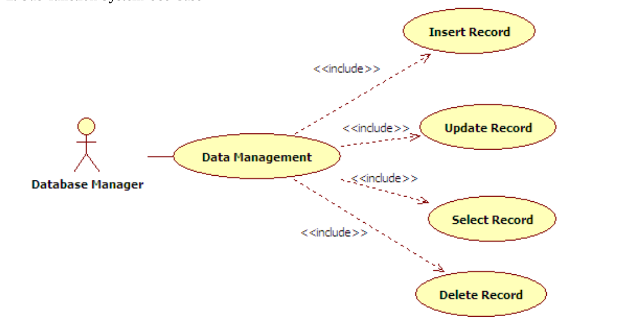
2.9.1 Insert Record
1. Introduction
Insert a record into the database table.Corresponding SQL statement: INSERT INTO<table name> <column name list>VALUES<insert value list>.
2. Inputs
Database name, table name, key-value pair list of field name and field value .
3. Process
（1）Read the field record in the table.
（2）Check the integrity constraint.
（3）Assign values to the autoincrement field and default field.
（4）Save records into the record file
4. Output
Record file, record file name:[Table Name].trd.

2.9.2 Update Record
1. Introduction
Update the record in the database table.Corresponding SQL statement: UPDATE <table name> SET<column name>=<update value>[WHERE <search condition>].
2. Inputs
Database name, table name, key-value pair list of field name and field value .
3. Process
（1）Read the field record in the table.
（2）Check the integrity constraint.
（3）Find the record to be updated( find through the primary key).
（4）Update the record to the record file.
4. Output
Record file

2.9.3 SELECT Record
1. Introduction
Query the records in the table.Corresponding SQL statement: SELECT* FROM <table name> [WHERE <search condition>].
2. Inputs
Database name, table name .
3. Process
（1）Read the database table information.
（2）Read the record information in the table.
（3）Return all the record information.
（4）Display the records.
4. Output
Display the records in the view of the interface.

2.9.3 DELETE Record
1. Introduction
Delete the record in the database table.Corresponding SQL statement: DELETE FROM <table name> <<insert value list>.
2. Inputs
Database name, table name, key-value pair list of field name and field value .
3. Process
（1）Read the database table information.
（2）Locate to the record of the table to be deleted.
（3）Update the record files.
（4）Updated the index files.
4. Output
Update index files.
Update record files.

3.0 Index Management
Establish the index for the key field in the database table. In the data operation, optimize the query with the index.
3.1 Client Management
Implement transaction management function in the database.
3.2 Index Management
Implement the functions of database integrity constraint check and management.
3.3 Database Management
Implement the functions of database backup and recovery.
3.4 Security Management
Implement user management,permission management.

3.5 Data Information
3.5.1 Data Type

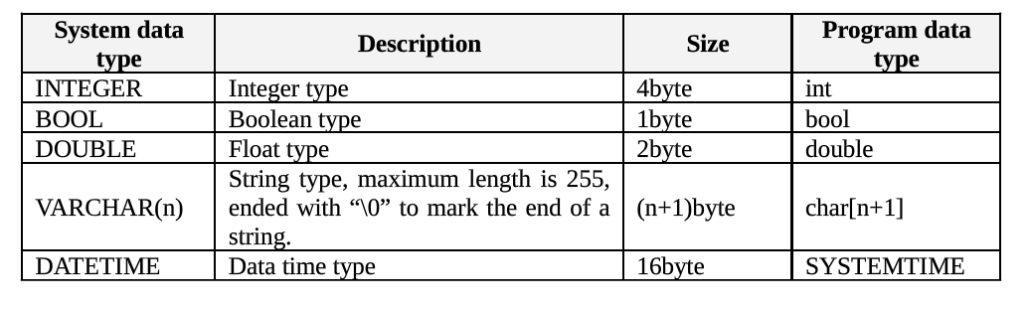
3.5.2 Integrity
3.5.2.1 Entity Integrity
PRIMARY KEY
3.5.2.2 Referential Integrity
FOREIGN KEY
3.5.2.3 User-defined Integrity
- CHECK
- UNIQUE
- NOT NULL
- DEFAULT
- INDENTITY

3.5.3 Database file
This system is a relational database management system. It stores data with the binary file.
- File Design
The files in DBMS are mainly divided into two types:data definition file and data file.
- Data definition file: saves the definitions of various objects in DBMS.
- Data file: saves various data in DBMS.
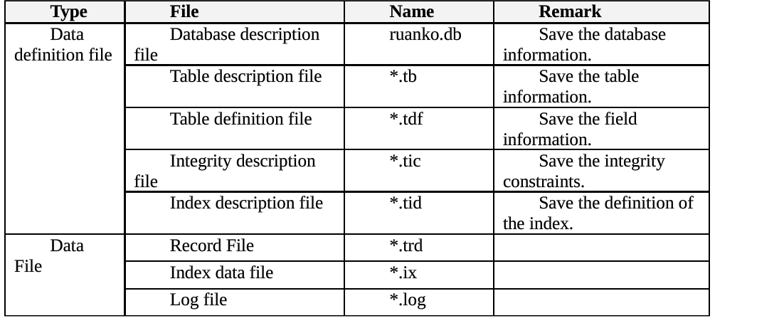
- File Structure
The database management system supports multi-database. A database can include many table. A table includes the data of the table definition, integrity constraint, index, record and so on.
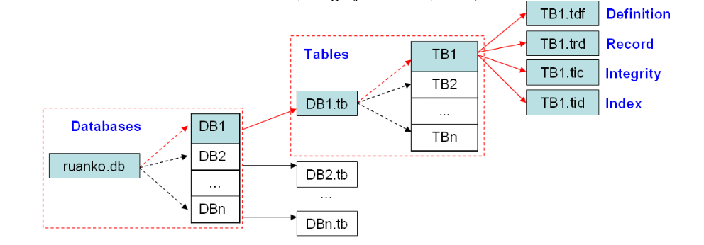
- File Structure
Taking [DBMS_ROOT]as the root directory, each database creates a folder to save various files in the database .Path:[DBMS_ROOT]\data\DB_NAME\.
Example: create a “Ruanko” database, and create “Student” table in the database. The presented directory structure is as follows:
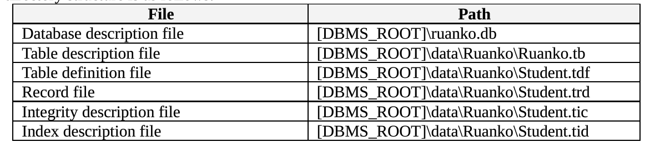

3.5.4 Database Description File
3.5.4.1 File Name
Ruanko.db

3.5.4.2 Database Information Structure

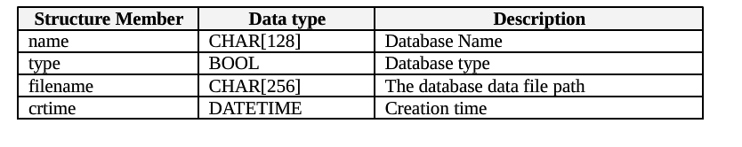

3.5.5 Table Description File
3.5.5.1 File Name
[Database_Name].tb
3.5.4.2 File Structure
3.5.4.3 Table Information Structure
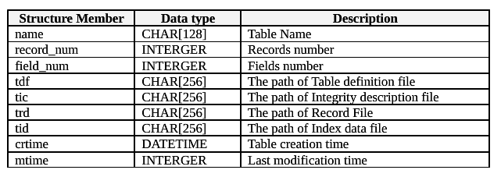

3.5.6 Table Definition File
3.5.6.1 File Name
[Table_Name].tdf
3.5.6.2 File Structure
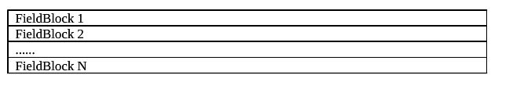
3.5.6.3 File Information Structure
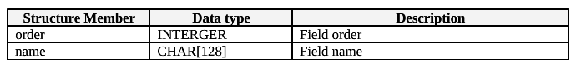
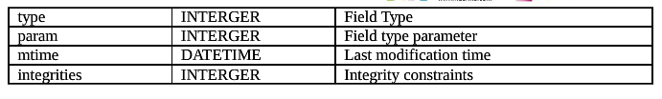

3.5.7 Record File
3.5.7.1 File Name
[Table_Name].trd
3.5.7.2 File Structure
3.5.7.3 Record Information Structure
- In DBMS, a record store format by user-defined.
- Based on the characters of data storage, all of the blocks and the field size are stored in the adjustment of a multiple of 4, in order to improve the efficiency of the data read.

3.5.8 Integrity Description File
3.5.8.1 File Name
[Table_Name].trd
3.5.8.2 File Structure
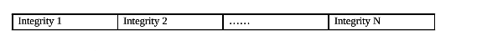
3.5.8.3 File Information Structure
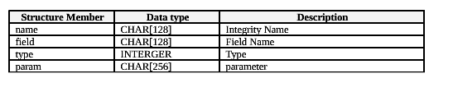

3.5.9 Index Description File
3.5.9.1 File Name
[Table_Name].trd
3.5.9.2 File Structure
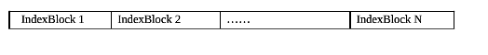
3.5.9.3 Index Information Structure

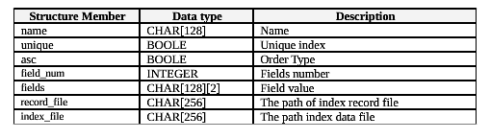
3.5.9.4 Index data file
File Name:[index_name].jx
Folder:Table folder
Index Name:[Field_Name]Index

4 Interface Requirements

4.1 User Interface

For most users, screens are larger than 17 inches, the resolution is 1024*768(it is 600*800 in a few cases ), and software interfaces should adapt to the screen dimension

4.2 Software Interface
This is windows application program with GUI.

5 Overall Design Constraints

5.1 Standards compliance

New specifications can be added if they conform to existing items in the following standards of the network log analysis system:

Ruanko COE Technical Requirements and Specifications
Ruanko COE Programming Requirements and Specifications

5.2 Hardware Limitations

Minimum configuration on a computer: CPU: 1 GHZ; Memory: 128 MB

5.3 Technology Limitations

File format: binary mode file format. Coding standard C++ Coding standard.

6 Software Quality Attributes

6.1 Reliability

Adaptability: New services and functions can be easily added to the system on the basis of its basic functions, without affecting the architecture of the original website system. The system can adapt to browsers of multiple versions.

Fault tolerance: In the case of system crashes, memory insufficient, it will not cause the system failure and the system can normally power off&restart.
Recoverability: The system should be able to run properly after a fault is resolved.

6.2 Usability

Usability: The interface design should be reasonable, concentrating system functions and making the system user-friendly. The system should block users’ illegal input data or operations, provide wizards and notes for complex processing, and provide users with handy help information

7 Requirements Classification
Requirement ID | Requirement Name | Classification
2.6.1 | Create Database | A
2.6.2 | Drop Database | C
2.7.1 | Create Table | A
2.7.2 | Alter Table | C
2.7.3 | Drop Table | C
2.8.1 | Add Field | A
2.8.2 | Alter Field | C
2.8.3 | Drop Field | B
2.9.1 | Insert Record | A
2.9.2 | Update Record | B
2.9.3 | Select Record | A
2.9.4 | Delete Record | C
3.0 | Index Management | A
3.1 | Client Management | B
3.2 | Transaction Management | C
3.3 | Integrity Management | B
3.4 | Database Maintenance | C
3.5 | Security Management | C

Importance of requirements is classified as following:
A. Mandatory: absolutely essential features, without which the product development will be canceled.
B. Important: unessential features that may affect the viability of the product.
C. Nice to have: desired features, the absence of which will not affect the product viability.

